|  |  |
| --- | --- |
| **PROJECT NAME:** | P17: Contribution assessment in team projects |
| **STUDENT NAME:** | Connor Lack |
| **STUDENT ID:** | 103992223 |

**Cumulative Summary**

|  |  |  |  |
| --- | --- | --- | --- |
| **Week #** | **Major work done this week** | **Total hours spent this week** | **Cumulative Total** |
| 1 | Brainstorming ideas for the project and researching potential topics | **2** | **2** |
| 2 | Learning about frameworks and finalising / submitting team documentation. | **2.5** | **4.5** |
| 3 | * Setup meeting with Client and contacted absent team-member * Client Meeting Q&A * Completion of Team and Project Plan * Academic Research of contribution in group projects * Creation of Trello Board | **11.5** | **16** |
| 4 | * Creation of Jira and Confluence * Sprint Planning * Research Report - Research on integration of APIs and AI | **12.5** | **28.5** |
| 5 | * Concept Design for Webapp Dashboard * Learning Pandas, NumPy, and Matplotlib * Design of System Solution * Organise Demonstration Date * Development of Slideshow Presentation | **16.5** | **44.5** |
| 6 | * Present Demonstration * Sprint Report * Begin planning Sprint 2 | **6** | **50.5** |
| 7 | * Set up GitHub Repo * Connect NodeJS and ReactJS * Method to import and store GitHub API data * Begin development of algorithm for analysing project artifacts | **9** | **59.5** |
| 8 | * Document data analysis using python AI packages * Implementation of Document Analysis onto repo * Set up Demonstration meeting | **9.5** | **69** |
| 9 | * Demonstration to client * Attendance Excel sheet parsing * Demonstration transcription * Analysis of multiple document types | **8** | **77** |
| 10 |  |  |  |
| 11 |  |  |  |
| 12 |  |  |  |

|  |  |  |  |
| --- | --- | --- | --- |
| **WEEK # 1** | **1** | | |
| **Dates covered:** | **4/08/2025 – 10/08/2025** | | |
| **TASKS** | **STATUS** | **TIME SPENT** | **ACTION ITEM/NOTE/EVIDENCE** |
| Brainstorming project ideas | Completed | **1** | Creation of a Venn diagram detailing possible routes we could go |
| Researching potential project topics | Completed | **1** | Looked into possible directions, including AI in contribution assessment |
| **TOTAL WEEKLY TIME SPENT** |  | **2** |  |

**Summary/weekly reflection for Week #1:**

* **Key tasks done / things attended:**
  + Brainstorming and initial research for project ideas with the team.
* **Key things learned about Computing Technology projects:**
  + Important to have a realistic scope for the project
* **Any literature read and key things learned:**
  + Read parts of a research paper “Assessing individual contribution in a team project using Learning Analytics”
* **Issues/problems/Challenges**
  + A bit of a struggle with communication on my end due to chaotic schedule that will be resolved.

**Plan for the next week:**

|  |  |
| --- | --- |
| **TASKS PLANNED FOR NEXT WEEK** | **EXPECTED COMPLETION** |
| Finish Group email to client Designate Team roles | YES |
| Begin drafting and writing the team project plan | YES |

|  |  |  |  |
| --- | --- | --- | --- |
| **WEEK # 2** | **2** | | |
| **Dates covered:** | **11/08/2025 – 17/08/2025** | | |
| **TASKS** | **STATUS** | **TIME SPENT** | **ACTION ITEM/NOTE/EVIDENCE** |
| Researching frameworks (etc. React) to use | In Progress | **1.5** | Compared frontend options |
| Finish Group email to client | In Progress | **1** | Draft prepared, needs all team members introductions |
| Designate Team Roles | On Hold | **0** | Will be declared during group discussion next meeting |
| **TOTAL WEEKLY TIME SPENT** |  | **2.5** |  |

**Summary/weekly reflection for Week #2:**

* **Key tasks done / things attended:**
  + Attended team meeting – discussing roles and planning the best available timeslots for future discussions.
  + Researched frontend frameworks and helped draft group email to client.
* **Key things learned about Computing Technology projects:**
  + Planning early is very important, allows for more flexibility and helps avoid delays later on in the project.
* **Any literature read and key things learned:**
  + Near completion of watching and partaking in React JS crash course to gain a better idea of the framework <https://www.youtube.com/watch?v=w7ejDZ8SWv8>
* **Issues/problems/Challenges**
  + Communication with a few team members that weren’t available for our team meeting to delegate roles.

**Plan for the next week:**

|  |  |
| --- | --- |
| **TASKS PLANNED FOR NEXT WEEK** | **EXPECTED COMPLETION** |
| Completion of Team and Project Plan | YES |
| Assign roles to each team member | YES |
| Come to an understanding with team about the scope and direction we want to take the project. | YES |
| Complete Research report | YES |

|  |  |  |  |
| --- | --- | --- | --- |
| **WEEK #3** | **3** | | |
| **Dates covered:** | **18/08/2025 – 24/08/2025** | | |
| **TASKS** | **STATUS** | **TIME SPENT** | **ACTION ITEM/NOTE/EVIDENCE** |
| Complete Team and Project Plan | Completed | **3.5** | Completion of:   * Teamwork Roadmap * Shared Documentation * Risk Mitigation * Problem Statement * Scope |
| Assign roles to each team member | Completed | **1** | Roles assigned to all team members as evident in the Team and Project Plan. |
| Meet with client and discuss the problem statement and scope of project | Completed | **1** | Scheduled and organised a Microsoft Teams meeting with Tanjila Kanij, documenting the questions and answers that took place. Team now understands the scope and direction to take the project. |
| Complete Research Report | In Progress | **2** | Started research report |
| Creation of Trello board for sprint tasks. | Completed | **1** | Creation of Trello board for team to stay atop of tasks  Trello board: |
| Academic Research of contribution in group projects | In Progress | **3** | Read through and documented key details in research papers: <https://www.sciencedirect.com/science/article/pii/S1877050920314770>  <https://arxiv.org/abs/2408.07082> |
| **TOTAL WEEKLY TIME SPENT** |  | **11.5** |  |

**Summary/weekly reflection for Week 3:**

Key tasks done / things attended

* The key tasks completed this week were organising and partaking in the meeting with our client and finally introducing ourselves to her. This was a very insightful meeting, as it gave the team a far better understanding and greater insight into what needs to be accomplished for this project to come to fruition. The project purpose, objectives and scope were made clear.
* The client meeting allowed for the team to make a start on and eventually complete the Project and Team Plan for the project.
* Creation of the Trello board should help our team further down the line with staying accountable and should help Jason (Scrum Master) keep an eye on the progress of everything.

Key things learned about Computing Technology projects

* Consistent Communication with both the team and client is vital. It is very easy to fall behind on tasks, falling into the trap where both myself and the team “can do it later” or “will do it later” – delaying completion when the task should realistically be started immediately.

Any literature read and key things learned

* Evaluating Source Code Quality with Large Language Models (Simões & Venson, 2024)
  + Discussed whether LLMs could evaluate source code quality, and clarity. Both aspects previously considered exclusive to human judgement. Through comparison of GPT 3.5, GPT 4-o, and SonarQube’s metrics, it was found that GPT-4o gave higher scores to code that SonarQube deemed not as pivotal, and GPT 3.5 showed correlation with SonarQube’s metrics with it’s ability to capture aspects like readability.
    - Main takeaway was that LLMs have a potential for analysing code quality, however reliability and consistency need more research.
* Assessing Individual Contribution in a Team Project using Learning Analytics (Shettar et al., 2019)
  + This research paper shares the same problem we as a team are trying to tackle during our project “Assessing individual contributions in group projects is challenging. Traditional grading can be biased and may not fairly represent each student’s work.” They attempted to use Learning analytics within a Learning Management System to track discussions, engagement and student actions. They found that the analytics framework was able to identify individual contributions with decent accuracy.
    - This proves that a data-driven approach is possible using Learning Analytics to fairly evaluate students within teams.

Issues/problems/Challenges

* The team didn’t make as quick of a start to the document as I would have liked. W we originally planned to complete the document Saturday, giving ourselves a day of proof-reading. However, come to Sunday morning and the only person who has contributed to the document was me. I took it upon myself to complete the majority of the document, writing the Teamwork Roadmap, Shared Documentation, Risk Mitigation, Problem Statement and Scope.

**Plan for the next week:**

|  |  |
| --- | --- |
| **TASKS PLANNED FOR NEXT WEEK** | **EXPECTED COMPLETION** |
| Completion of Individual Report | YES |
| Further research into the implementation of AI with Learning Analytics. Research into Language Models. | YES |
| Ascertain what we want to achieve as a team for the first sprint. Detail what we should all research and perhaps begin compiling the information together. | YES |
| Email client and get Student Project Agreement signed off at the beginning of the week. | YES |

|  |  |  |  |
| --- | --- | --- | --- |
| **WEEK #** | **4** | | |
| **Dates covered:** | **25/08/2025 – 31/08/2025** | | |
| **TASKS** | **STATUS** | **TIME SPENT** | **ACTION ITEM/NOTE/EVIDENCE** |
| Individual Report | Completed | **10** | Individual Report was completed and submitted. |
| Creation of Jira and Confluence | Completed | **1.5** | Team Jira was created to help scrum-master and team with assigning tasks and delegating research. |
| Team Sprint Planning | Completed | **1** | Meeting was held to determine what the aim of the sprint should be. |
| **TOTAL WEEKLY TIME SPENT** |  | **12.5** |  |

**Summary/weekly reflection for Week 4:**

Key tasks done / things attended

* Completion of the Individual Report took a majority of my time this week outside of classes and work. The report admittedly was submitted late and will incur a penalty; this could have been avoided with proper planning and beginning the report at an earlier date. This research also helped me with contributing to the group research matrix, as the research for the report fell hand in hand with the goal of our first sprint – that being research and development.

Key things learned about Computing Technology projects

* Properly documenting and reading through journals and research papers takes time. Research matrixes are an excellent way for documenting your findings and sharing them with the team as they provide insightful information in a simple layout.

Any literature read and key things learned

Below listed is the key literature I researched and studied in detail for the report. Other research papers were used but weren’t covered as in depth due to time constraints:

* The impact of unequal contributions in student software engineering team projects' — Journal of Systems and Software  
  <https://www.sciencedirect.com/science/article/pii/S0164121223002340>
* Software engineering team project courses with industrial customers: Students’ insights on challenges and lessons learned  
  <https://www.sciencedirect.com/science/article/pii/S0164121225001098>
* Assessing individual contribution in a team project using Learning Analytics  
  <https://www.sciencedirect.com/science/article/pii/S1877050920314770>
* Code-quality evaluation scheme for assessment of student contributions to programming projects

<https://www.sciencedirect.com/science/article/pii/S0164121222000358>

* Peer assessment of individual contributions to a group project: Student perceptions  
  <https://www.sciencedirect.com/science/article/pii/S1078817408000321>

Issues and problems:

* Two of our team-members didn’t show up to the weekly scheduled meeting Saturday morning. The team members being Kavindu Bhanuka Weragod and Md Hridoy Mia. Kavindu was at the dentist and gave us a heads up which is excellent because communication prior helps the team get a better understanding of the situation. Md Hridoy Mia also didn’t attend our brainstorming / sprint planning meeting Monday night and didn’t give any reasoning or notice for doing so.
* I will address giving notice in the Monday meeting and perhaps create a weekly document on Jira that the team fills out every Monday to put in their work shifts for the upcoming week to see if we need to reorganise meetings.

**Plan for the next week:**

|  |  |
| --- | --- |
| **TASKS PLANNED FOR NEXT WEEK** | **EXPECTED COMPLETION** |
| Further Research and Development on AI and API integration. Want to shoot for 15-20 hours. | YES |
| Organise date for client demonstration | YES |
| Start developing the PowerPoint presentation as a team. Finalise the design, and come to an agreement on the method for development and implementation | YES |

|  |  |  |  |
| --- | --- | --- | --- |
| **WEEK #** | **5** | | |
| **Dates covered:** | **01/09/2025 – 07/09/2025** | | |
| **TASKS** | **STATUS** | **TIME SPENT** | **ACTION ITEM/NOTE/EVIDENCE** |
| Design of System Solution | Completed | 2 | Development of the system architecture design (refer to diagram below) |
| Learning Pandas, NumPy, and Matplotlib | In Progress | 9 | Learning and implementing AI libraries  (refer to screenshots below) |
| Concept Design for Webapp Dashboard | Completed | 3 | Development of a webapp concept |
| Organise Demonstration Date | Completed | 0.5 | Date organised for demonstration |
| Development of Slideshow Presentation | In Progress | 2 | Slideshow development |
| **TOTAL WEEKLY TIME SPENT** |  | **16.5** |  |

**Summary/weekly reflection for Week 5:**

Key tasks done / things attended

* Design of System Solution
  + A core task for this week was to create the architectural design of the project. The plan was to create a 3-Tier architecture design, with a data input layer, processing layer (backend), and output layer (frontend). The architecture design details how data will be collected and stored into datasets, before eventually being normalized and utilised for the student contribution score. The design also details the technological stack that will be utilised for frontend development.
  + Using an Internal Peer review would make it easier for the webapp to integrate the data.
  + Implementation of the idea of the team leader having a csv that he/she fills out with the attendance of all team members each week for meetings, and then at the end of the semester uploads to the webapp.A diagram of a company

    AI-generated content may be incorrect.
* Development of a concept for the webapp
  + Using Adobe XD, I created a concept for what the webapp should look like. Did a bit of research on the internet for dashboards and designs I find really aesthetically pleasing. The webapp is also supposed to be a summary of all information but should also display intricate information when required. In this design, I think I perhaps went a little overboard on some of the statistics, as some of them aren’t very important. However, I do like the general concept, especially with the commits tab. I believe it provides a very good skeleton of what could be.

* Learning python libraries for AI and ML
  + This week I undertook the task of learning popular and common python libraries for AI and ML purposes 🡪 I ended up focusing on pandas and NumPy for data cleaning and implementation, and matplotlib for data visualisation.

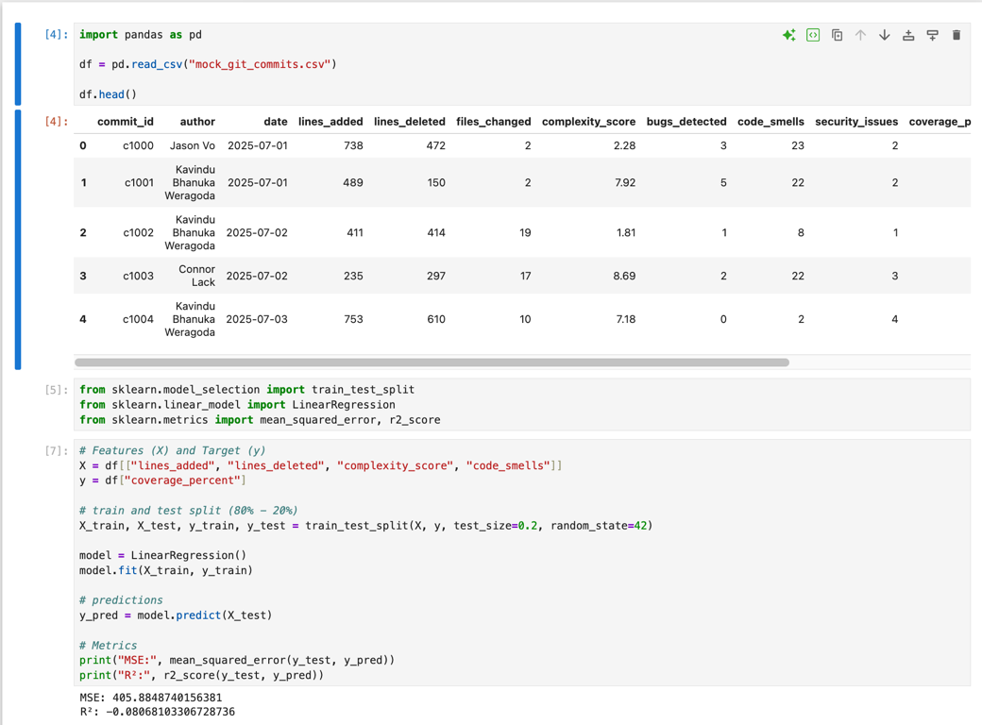

To incorporate some practical skills that may come in handy later in the project, I utilised a dataset that replicates what data may be pulled from the GitHub API when we progress past the manual upload of files in the alpha of the webapp, into the integration of APIs.

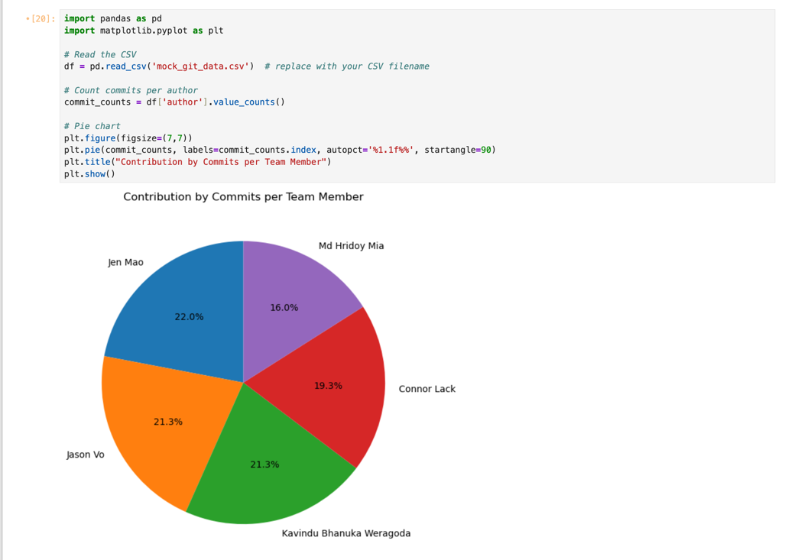

Key things learned about Computing Technology projects

* There is always more to learn. And when I think you’ve learnt a decent amount, I realise that it’s only a drop in the bucket. This is mostly in regard to AI and ML libraries, as there is so much to learn and experiment with, especially different models (linear regression, decision trees, random forests).

Any literature read and key things learned

* Learn Python for Data Science – Full Course
  + <https://www.youtube.com/watch?v=CMEWVn1uZpQ&t=50147s>
  + Very informative video. Watched up to 14ish hours, need to finish the video to cover the topic of ML in python and using scikit-learn for different models.

Issues and problems:

* Two team meetings were scheduled for this week. Wednesday 10pm and Saturday 11am.
* For the Wednesday session two team members were missing, Hridoy and Jen. Hridoy messaged a few hours prior to the meeting stating he would be busy with his job and Jen didn’t manage to message prior to the meeting.
* On Saturday, it was only Jason and me that attended the meeting, with the other three members absent. Jen couldn’t attend because of work (this was fine since she put in her unavailability at the start of the week), however neither Hridoy nor Kavindu attended – both didn’t provide reasoning.
* It has been well established prior that if a team member can’t attend a meeting, they are to give formal notice out of respect for the rest of the team.

**Plan for the next week:**

|  |  |
| --- | --- |
| **TASKS PLANNED FOR NEXT WEEK** | **EXPECTED COMPLETION** |
| * Client Demonstration | Yes |
| * Begin Development of Application   Experiment with integrating data from GitHub and Google Docs. | Yes |

|  |  |  |  |
| --- | --- | --- | --- |
| **WEEK #** | **6** | | |
| **Dates covered:** | **10/09/2025 – 16/09/2025** | | |
| **TASKS** | **STATUS** | **TIME SPENT** | **ACTION ITEM/NOTE/EVIDENCE** |
| **Client Demonstration** | Completed | 1.5 | Demonstrated findings from Sprint 1 to client. |
| **Sprint Report** | Completed | 3.5 | Completed and submitted sprint report for Sprint 1. |
| **Planning Sprint 2** | In Progress | 1 | Begun planning Sprint 2 on Confluence. |
| **TOTAL WEEKLY TIME SPENT** |  | **6** |  |

**Summary/weekly reflection for Week 6:**

Key tasks done / things attended

* Client Demonstration
  + The team presented the Sprint 1 research and development to the client. This demonstration detailed the design of the architecture and the conceptual mock-ups for the web application. Methods for data extraction and analysis were detailed for different project artifacts.
* Sprint Report
  + The team completed the sprint report, detailing what was achieved in Sprint 1 and the general thoughts and feelings about how we feel we performed as a group. I completed the Sprint Plan and the Sprint Progress sections of the report.
* Planning Sprint 2
  + A planning document was created to plan Sprint 2 and assign tasks to each team member early on to ensure progress can begin as soon as possible in developing our relevant areas. For myself, this will be developing and experimenting with an algorithm that analyses all the project artifacts.

Key things learned about Computing Technology projects

* Rehearsals are very important when presenting information to clients. As a team we only rehearsed once prior to the presentation due to our lack of preparation. If we had completed the presentation earlier, we could’ve practiced verbalising our sections and timed our speaking segments more optimally to ensure that the pacing of the presentation allows for all team members to speak.

Any literature read and key things learned

* No new content was consumed this week.

Issues/problems/Challenges

* As written prior, the completion of the PowerPoint was very behind the expected finish date. This resulted in a presentation to the client that wasn’t very well rehearsed or practiced – causing some team members not to be able to speak their segments.
* Team members didn’t get a start on the Sprint Report as early as I would’ve liked. The document hadn’t been contributed to by anyone except me until the day of submission. Due to this, I completed the first two segments of the document because I was unsure if the other team members would contribute to the document. They did end up completing the other parts later in the evening.
* I also fell ill during the week, as I contracted the flu so I wasn’t able to get as much work done as possible during the mid semester period.

**Plan for the next week:**

|  |  |
| --- | --- |
| **TASKS PLANNED FOR NEXT WEEK** | **EXPECTED COMPLETION** |
| Assign tasks to each team member and assign story points. | Yes |
| Create GitHub repo for team to begin development on local-hosted version of the project. | Yes |
| Develop and experiment with algorithm for calculating individual contribution for students. | Yes |

|  |  |  |  |
| --- | --- | --- | --- |
| **WEEK #** | **7** | | |
| **Dates covered:** | **22/09/2025 – 28/09/2025** | | |
| **TASKS** | **STATUS** | **TIME SPENT** | **ACTION ITEM/NOTE/EVIDENCE** |
| Set up GitHub Repo | Completed | **1.5** | <https://github.com/gitconzo/contribution-capstone> |
| Connect NodeJS and ReactJS | Completed | **2** | *Snippets below* |
| Create function to import data using GitHub API | Completed | 2.5 | *Snippets below* |
| Begin development of algorithm for analysing project artifacts | **In Progress** | **3** | *Snippets below* |
| **TOTAL WEEKLY TIME SPENT** |  | **9** |  |

**Summary/weekly reflection for Week 7:**

Key tasks done / things attended

Listed above are the tasks that were delegated to the team this week for Sprint 2. As stated, my tasks were to Prototype an algorithm for GitHub data, Create the Git Repository, and Import and clean GitHub data for the algorithm.

Setup GitHub Repo

* + The GitHub repo was established and set up, this required setting up the project to have all relevant dependencies installed, including npm, node, and react. I had to conduct research to achieve this, as this was the first time I was linking Node and React.JS together in a project. Express is used to create a server on port 5002. The reason that 5002 was selected was because I originally attempted port 5000, but I kept getting an error. After some headaches and research, it was detailed that apparently Apple reserve port 5000 for their MacBook and instantly claim the port whenever it gets reset. So, I switched to port 5002 and it fixed the issue. The frontend fetches the /api/scores using a HTTP GET request from React, Node receives the request and executes the route handler before sending a JSON payload over HTTP. Frontend receives this JSON.
* Import and clean GitHub data
  + I created an algorithm fetchData() to fetch data from GitHub using the API and repo details of the project.

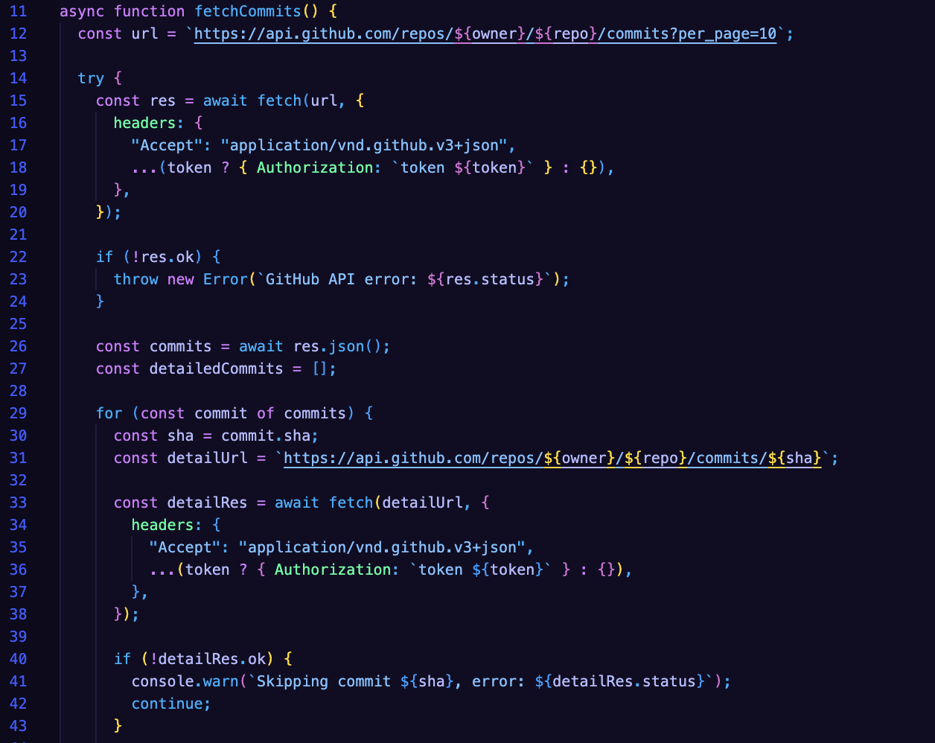

The owner and repo tell the script which repository to fetch the commits from. The repo is public, but if it becomes private, token will be used for authentication.

It then fetches a list of commits from the repo, sending a request to the GitHub API to get the current 10 most recent commits. The data is parsed into a JSON response.

In for(const commit of commits) {} Each commit requests more details such as additions, deletions, and author information – giving us more stats to work with instead of just a summary.

detailedCommits.push({}) contains all relevant information for the commit and stores the info into the detailedCommits array.

The info is then stored into data/commits.json.

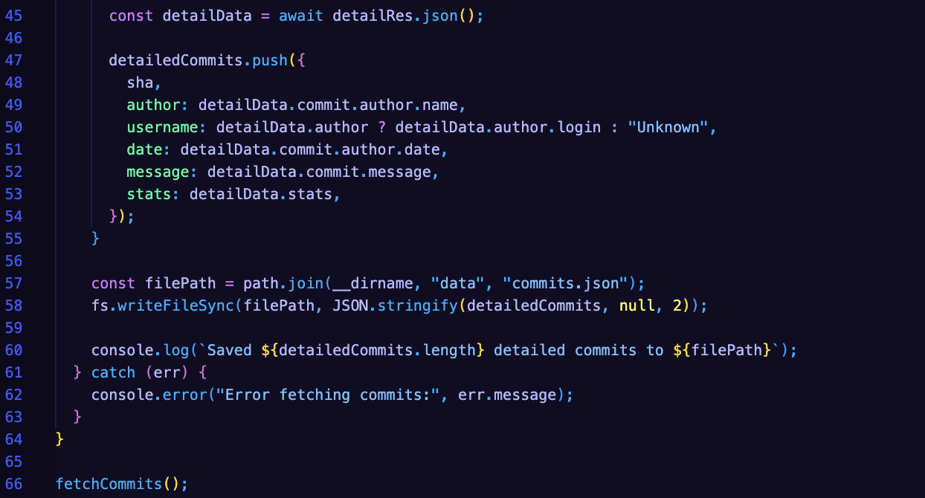

* Creation of algorithm for giving normalized score based on contribution of individual using project artifacts from GitHub

This code experimentation is based on Jason’s design for the algorithm that will analyse the code artifacts, normalize the data and give a contribution score on different metrics. This snippet is a small experiment of how the code portion could potentially be analysed.

For the normalization, each author has commits, total lines added, and total lines deleted summed up – giving raw numbers.

In the Normalization function, the purpose is to scale all values to a range of 0-1 so that the metrics can be compared. Each metric is normalised separately from every author (commitsNorm, additionsNorm, and deletionsNorm).

Then a weighted sum is added which combines the normalized metrics into a single final score using the given weights. Weights are planned to be adjustable by the tutor and not hardcoded to ensure flexibility.

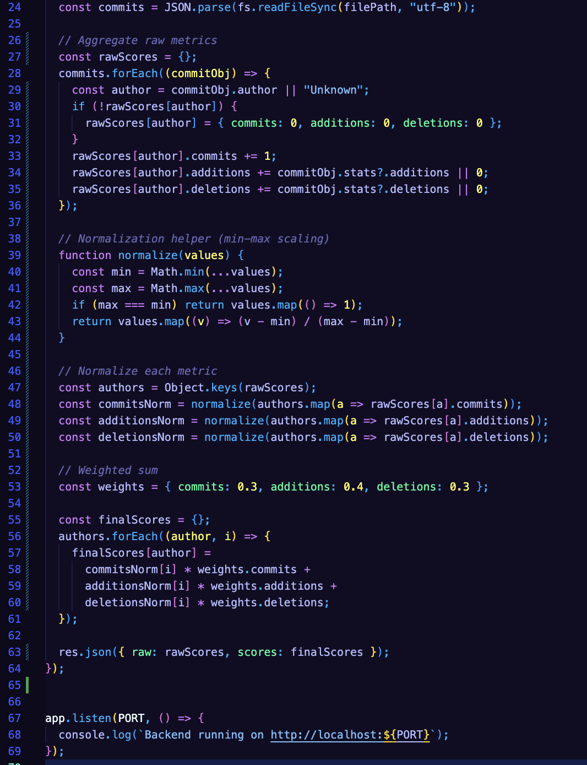

Key things learned about Computing Technology projects

Coding takes a long period of time, especially when learning new technologies. Setting up the repo took me longer than I thought I would need due to unforeseen bugs and issues. Will need to experiment more next week to try and use project artifacts from documentation.

Any literature read and key things learned

N/A

Issues/problems/Challenges

Jen, Kae, and Hridoy were given the task to complete their figma designs by Friday so we could look at them together. For the team meeting on Saturday morning, it was only Jason, Kae and myself that attended. Jen had apparently put her unavailability in beforehand but not announced it and Hridoy didn’t mention he could attend till afterwards 10 hours later stating he was sick the last two days. Hridoy and Jen were given Monday till Saturday to complete their designs and they didn’t even send anything to the discord about what they’d worked on at all so as a team we have to assume they didn’t complete their tasks. Communication is key in the team and Jason and myself are going to take a more proactive role in cementing this ideal into the team as we don’t want to fail.

**Plan for the next week:**

|  |  |
| --- | --- |
| **TASKS PLANNED FOR NEXT WEEK** | **EXPECTED COMPLETION** |
| Contact client for advice on algorithm approach and constructive criticism on three different website approaches. | Yes |
| Document data analysis using python AI packages. | Yes |

|  |  |  |  |
| --- | --- | --- | --- |
| **WEEK #** | **8** | | |
| **Dates covered:** | **29/09/2025 – 05/10/2025** | | |
| **TASKS** | **STATUS** | **TIME SPENT** | **ACTION ITEM/NOTE/EVIDENCE** |
| Document data analysis using python AI packages. | Completed | **6** | Refer to screenshots below |
| Implementation of Document Analysis onto repo | Completed | **3** | Refer to screenshots below |
| Contact Client for advice on website design approaches | In Progress | **.5** |  |
| **TOTAL WEEKLY TIME SPENT** |  | **9.5** |  |

**Summary/weekly reflection for Week 8:**

Key tasks done / things attended

This week my key task was designing and implementing a program that can parse the data of a word document and then summarise the information into a .json file that can be used to easily extract and display information on a web-app. This was implemented and designed so that the weekly worklog that is uploaded by students can be summarised and displayed on the web-app for the teacher / tutor to read the key information.

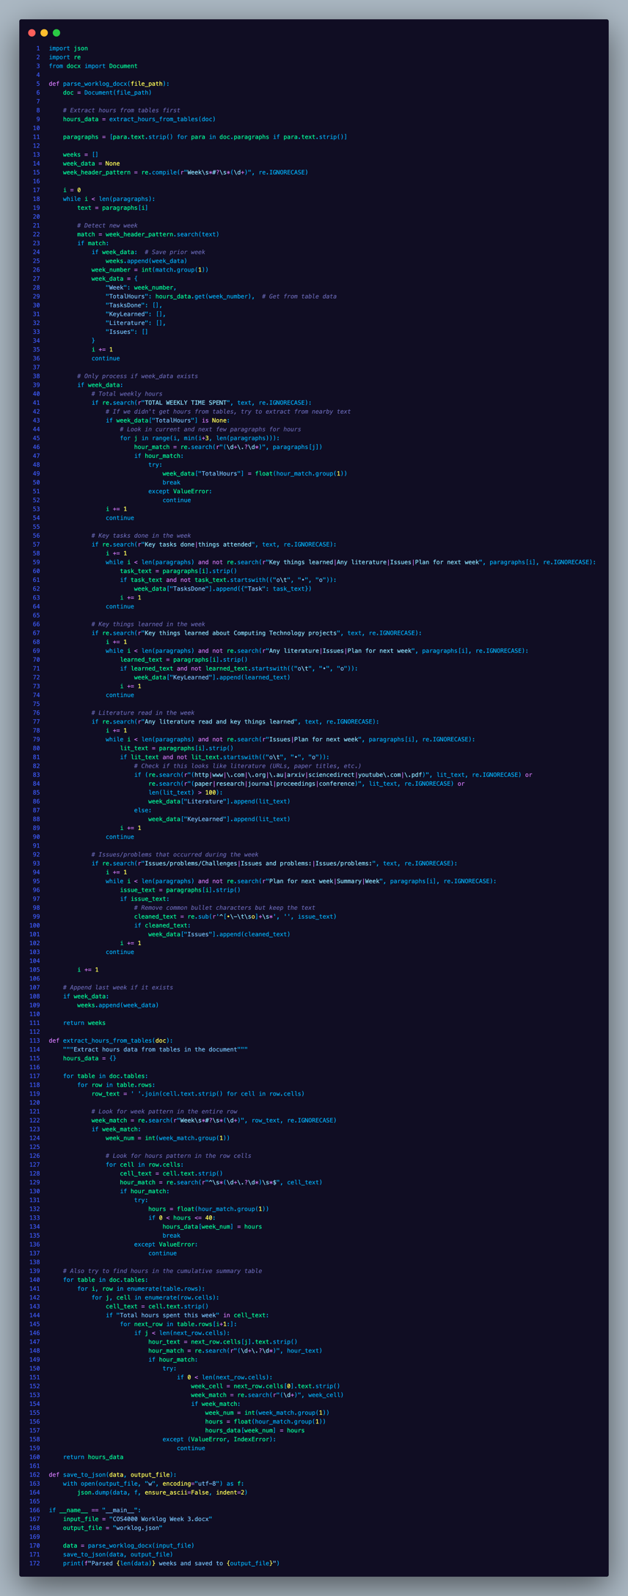

This code aims to extract all the key information using a tool called python-docx. python-docx is a python package that allows the raw .docx files to be parsed and read using python – from which it is converted into a .json file.

The code using python-docx works by creating a dictionary for each week where all the variables are stored (TotalHours, TasksDone, Literature, etc.).

The program then looks for key headings (such as “Key tasks done”, “Key things learnt”, etc.) where the data is written. The block consumes and stores all the information until it reaches the next key heading.

Detecting the total hours was a little more difficult, as it’s nested in a table. The hours_data dictionary stores the week number and the corresponding amount of hour spent working on the project during that week. To achieve this, it loops through each table in the document looking for the week pattern (what the week number would look like in regex 🡪 r”Week\s*#?\s*(\d+)”) and the number that looks like the hours (regex 🡪 r”\s*(\d+\.?\d*)\s*$”). If it is able to find both, then the data is stored in the dictionary.

Key things learned about Computing Technology projects

It always takes longer to learn or complete a task then you would typically think. Learning python-docx took me a substantial time and I had a lot of issues with the document not able to collect the hours data which resulted in me resorting to the regex to find it within the document. This was a solution that arrived after lots of hours of testing and trying other methods.

Issues/problems/Challenges

In terms of team synergy and overall effort, one of our team-members Hridoy isn’t doing the required amount of work that is expected of every team-member. He was assigned a Figma design and produced a single page that was originally a template from the internet. This would’ve likely been 30 minutes or less of work. He was instructed to redo it.

**Plan for the next week:**

|  |  |
| --- | --- |
| **TASKS PLANNED FOR NEXT WEEK** | **EXPECTED COMPLETION** |
| Demonstration to client | Yes |
| Creation of dashboard and document analysis tab for alpha | Yes |
| Analysis of multiple different document types | Yes |
| Database Implementation | In Progress |

|  |  |  |  |
| --- | --- | --- | --- |
| **WEEK #** | **9** | | |
| **Dates covered:** | **06/10/2025 – 12/10/2025** | | |
| **TASKS** | **STATUS** | **TIME SPENT** | **ACTION ITEM/NOTE/EVIDENCE** |
| Demonstration to client | Completed | 1 | Client Demonstration conducted on Thursday 9th October. |
| Transcription of client notes from demonstration | In Progress | 1 |  |
| Creation of Attendance script | Completed | 4.5 | *Screenshots below* |
| Analysis of multiple different document types | Completed | 1.5 | *Screenshots below* |
| **TOTAL WEEKLY TIME SPENT** |  | **8** |  |

**Summary/weekly reflection for Week 9:**

Key tasks done / things attended

I wrote a script using the python package ‘openpyxl’ that aims to extract all the key information from the attendance sheet so the data can be easily displayed on the front-end

The code works by reading each row of the Excel sheet and creating a dictionary for each week that stores the week number, date, absentees, and their reasons. It loops through each team member to check if they were present or absent, records absences, parses the “Name - Reason” text into a dictionary, and then at the end calculates each member’s overall attendance percentage across the semester by dividing the attended meetings by total meetings.

Client Demonstration was conducted on Thursday 9th of October for Sprint 2. We conducted multiple rehearsals beforehand and created the slideshow presentation to ensure that a helicopter overview was presented instead of a deep dive that could’ve potentially left the client feeling confused. The scripts developed for parsing information were demonstrated and the rule-based logic we’ve decided to move forward with was highlighted. Two conceptual web application designs were also presented.

I am currently in the midst of transcribing the clients feedback during the presentation to ensure that we are equipped for Sprint 3 and can complete the planning document as quickly as possible to ensure we can get started on development immediately.

Key things learned about Computing Technology projects

Rehearsals make a big difference when presenting information. In sprint 1 as a team, we lacked the forethought to practice our presentation due to time constraints, and this left us in a position where the client wasn’t confident in our abilities due to lots of jargon being presented. This time around, we practiced, timed, and refined out presentation so that it would give a clear idea of what we had been working on and allow for the client to ask questions.

Any literature read and key things learned

N/A

Issues/problems/Challenges

Hridoy was supposed to deliver a functioning high-level conceptual design of a web-application but ended up not delivering at all, instead using a template online for his work. Due to the low effort, as a team we came to the decision to remove his design from the client presentation to ensure that a professional standard is maintained to the client through presentation of high-quality work.

**Plan for the next week:**

|  |  |
| --- | --- |
| **TASKS PLANNED FOR NEXT WEEK** | **EXPECTED COMPLETION** |
| Plan Sprint 3 | Yes |
| Merge parsing scripts into repository | Yes |
| Confluence API integration research |  |
| Sprint Report Summary script | Yes |

|  |  |  |  |
| --- | --- | --- | --- |
| **WEEK #** | **10** | | |
| **Dates covered:** |  | | |
| **TASKS** | **STATUS** | **TIME SPENT** | **ACTION ITEM/NOTE/EVIDENCE** |
|  | Completed |  |  |
|  | Not started |  |  |
|  | On hold |  | Check with xyz |
|  |  |  |  |
| **TOTAL WEEKLY TIME SPENT** |  |  |  |

**Summary/weekly reflection for Week #:**

*-key tasks done / things attended*

*-key things learned about Computing Technology projects*

*-any literature read and key things learned*

*-Issues/problems/Challenges*

**Plan for the next week:**

|  |  |
| --- | --- |
| **TASKS PLANNED FOR NEXT WEEK** | **EXPECTED COMPLETION** |
|  |  |
|  |  |

|  |  |  |  |
| --- | --- | --- | --- |
| **WEEK #** | **11** | | |
| **Dates covered:** |  | | |
| **TASKS** | **STATUS** | **TIME SPENT** | **ACTION ITEM/NOTE/EVIDENCE** |
|  | Completed |  |  |
|  | Not started |  |  |
|  | On hold |  | Check with xyz |
|  |  |  |  |
| **TOTAL WEEKLY TIME SPENT** |  |  |  |

**Summary/weekly reflection for Week #:**

*-key tasks done / things attended*

*-key things learned about Computing Technology projects*

*-any literature read and key things learned*

*-Issues/problems/Challenges*

**Plan for the next week:**

|  |  |
| --- | --- |
| **TASKS PLANNED FOR NEXT WEEK** | **EXPECTED COMPLETION** |
|  |  |
|  |  |

|  |  |  |  |
| --- | --- | --- | --- |
| **WEEK #** | **12** | | |
| **Dates covered:** |  | | |
| **TASKS** | **STATUS** | **TIME SPENT** | **ACTION ITEM/NOTE/EVIDENCE** |
|  | Completed |  |  |
|  | Not started |  |  |
|  | On hold |  | Check with xyz |
|  |  |  |  |
| **TOTAL WEEKLY TIME SPENT** |  |  |  |

**Summary/weekly reflection for Week #:**

*-key tasks done / things attended*

*-key things learned about Computing Technology projects*

*-any literature read and key things learned*

*-Issues/problems/Challenges*

**Plan for the next week:**

|  |  |
| --- | --- |
| **TASKS PLANNED FOR NEXT WEEK** | **EXPECTED COMPLETION** |
|  |  |
|  |  |